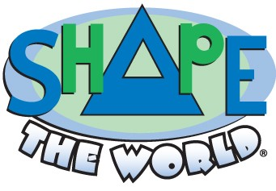

Vardo Gallery emerged as a home for the many works of art created by a young Nathan VanDeVelde. From the age of five, his artwork grew into a collection of drawings, paintings and stories. As a way of sharing with family and friends, we set-up a website in June 2005 under the name www.vardogallery.com. Over the next few years, we updated the site with new work and community accolades.
In January 2008, Nathan shared yet one more idea...for a game. He combined two of his favorite pastimes, using shapes and math, and developed a format so that everyone everywhere could have the simple pleasure of creating something new and have great fun sharing it. This idea resonated with family and friends to the point of envisioning a commercial product. As a result, we developed www.nathanology.com as the new home for “all things Nathan” and started a new site for the game, www.shapetheworld.com. As of 2014, we have combined the content of the websites and are moving forward with only shapetheworld.com.
Not only has Nathan exhibited an artistic gift he has demonstrated a true sense of charity and compassion. He realizes and appreciates the value of helping others and understands that efforts on any scale can have a positive impact on the world around us. The development of Shape the World, LLC was driven by a desire for actually “shaping the world” and working with people who shared our vision.

Despite receiving multiple awards, the economic conditions that arose shortly after the creation of the game made it difficult to develop distribution channels and many of the smaller specialty shops we supplied were closing their doors. We are hoping the economy will turn around for all of us and the game will find its niche in the marketplace some day, perhaps as an app! In keeping with our original goal, it seemed only natural that we share the bulk of the remaining inventory with as many families as possible, and we’re pleased to announce we donated over 2000 games to families and organizations working toward making the world a better place!

